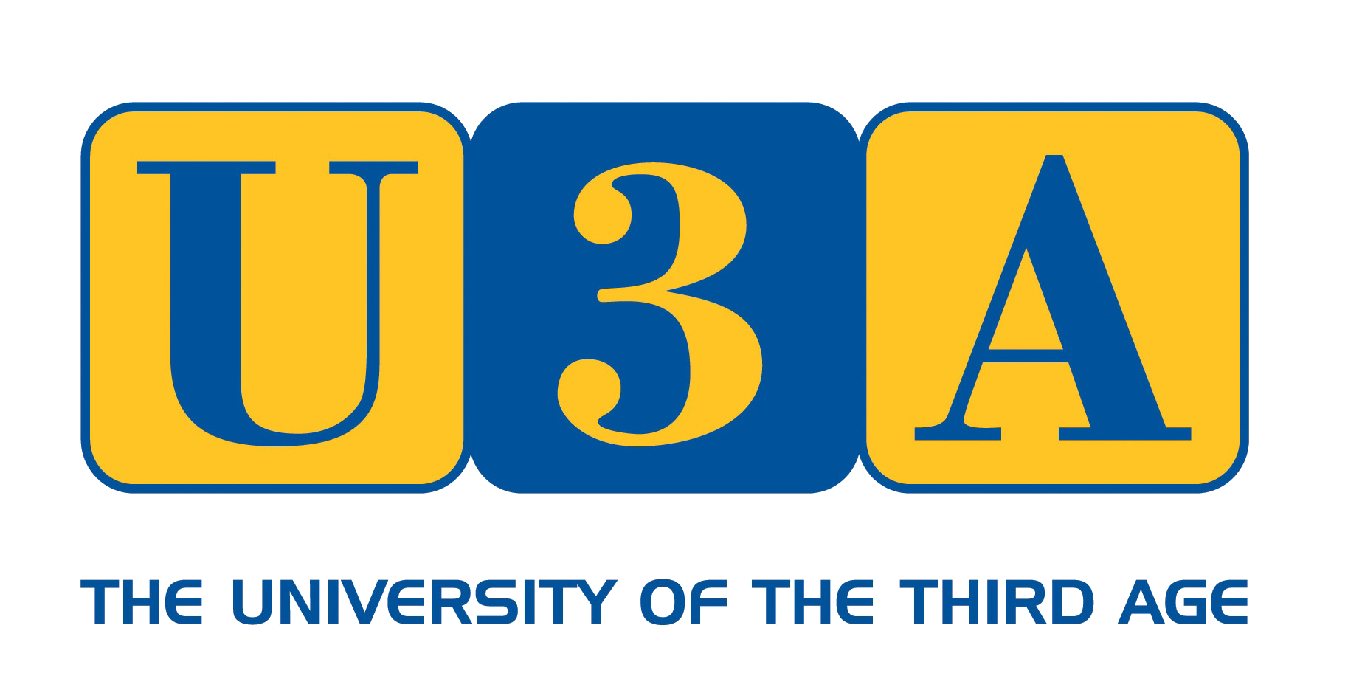 | ORKNEY U3A  Leisure & learning for  Retired People | 

Membership Application Form

Orkney U3A email address: info@orkneyu3a.org

Membership £10.00 per person
Subscriptions renewable at A.G.M. in April each year

Contact Details
Title: | Mr/Mrs/Miss/Ms
Forename:
Surname:
E-mail:
Mobile:
Address
Line 1
Line 2
County: | Orkney
Postcode:
Declaration
I wish to apply for membership of Orkney U3A.
I have read the accompanying “Orkney U3 - General Data Protection Regulations”.
Signature:
Date:
Payment
Ideally email your completed form to treasurer@orkneyu3a.org, with payment by BACS:
Account Name: | Orkney U3A
Sort Code: | 80-08-66
Account Number: | 06006445
Alternatively, send your completed form with payment (cheques made payable to Orkney U3A) to:
Treasurer: | Gill Lewis  Nether Scapa, St Ola, Kirkwall, KW15 1SD
Phone: | 01856 872218

ORKNEY U3A - GENERAL DATA PROTECTION REGULATION - GDPR
This is to let you know that Orkney U3A is aware of the General Data Protection Regulation (GDPR) that came into effect on 25 May 2018 and replacing the earlier Data Protection Act.
Our understanding of the legislation, in relation to membership groups such as Orkney U3A, is that we must ensure that:
- Members must be aware of what data is held and how it is used (and can ask at any time).
- Members have the right to ask for their data to be deleted from the database, again at any time.
The data we hold is that which you have given us on joining, or subsequently, i.e. usually your name, postal address, telephone number and email address. If you wish to have details of the exact data we hold about you, please ask and we will inform you immediately.
Your postal address is used only to send you any mail (if you have no email address). Your email address is used for informing you about U3A events, meetings and subscription reminders. We may also mention other non-U3A events that we know of and that might be of interest to you. Your phone number is used only if we can’t contact you by email and need to get in touch.
The data is stored in a dedicated u3a system called Beacon and accessible only by appropriate Committee Members. The data is backed up daily in a secure manner.
We do not share your details with other organisations or individuals. We do not do any profiling or processing of the data. Your data is never used for any kind of marketing or advertising other than that which directly relates to U3A matters and activities. This means that your data is only kept and used by the U3A for ‘legitimate interests’ (please see link at the bottom of the page for further details of this).
If, at any time, you wish to have your data, or any part of your data, removed from our records, please contact us and this will be done. Membership is considered lapsed 18 months after the receipt of the last subscription and your details will then be deleted from our records, or sooner if you request that.
If you have any immediate concerns or questions about the subject of GDPR in relation to Orkney U3A, please contact us via the Membership Secretary.
22/05/2018
NB. Further information on GDPR and ‘Legitimate Interests’ :
https://ico.org.uk/for-organisations/guide-to-the-general-data-protection-regulation-gdpr/

